- Use sklearn's PolynomialFeatures() to transform a dataset of mobile phone prices (features: RAM, storage) into polynomial features up to degree 2, and print the resulting feature matrix.

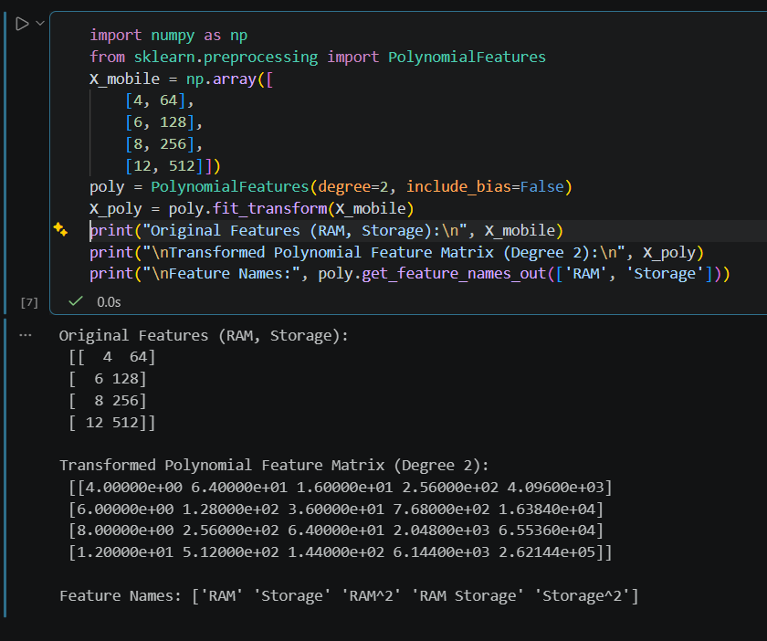

- Train both a LinearRegression and a Polynomial Regression (degree=3) model on a dataset of Zomato restaurant ratings versus number of reviews, then plot both predictions on the same chart to compare their fits. Use matplotlib for plotting and clearly label both curves.
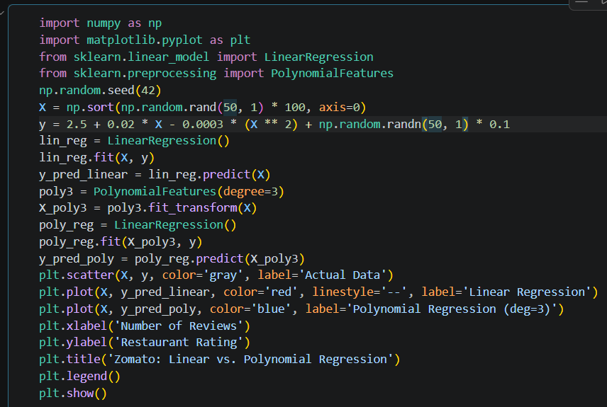

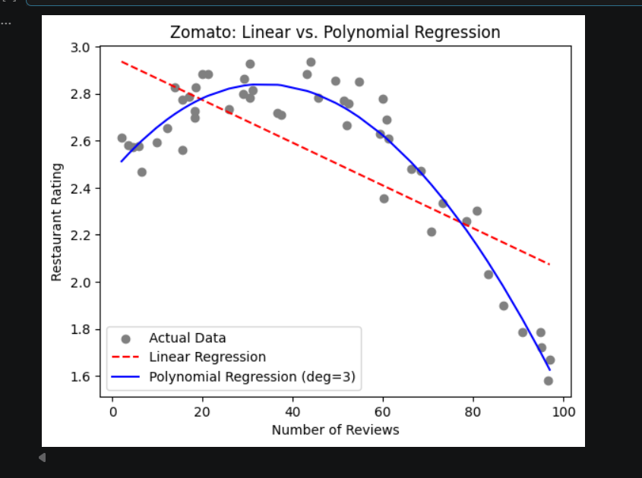

- Given a dataset where the relationship between followers and posts for Instagram users is non-linear, fit a polynomial regression model (degree=4) and check for overfitting by plotting the training and validation errors for degrees 1 to 5.

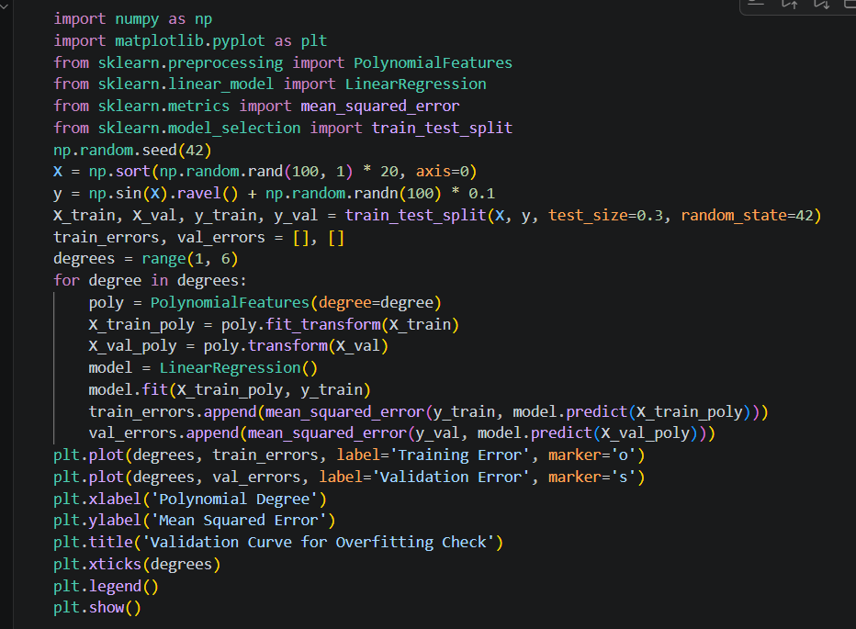

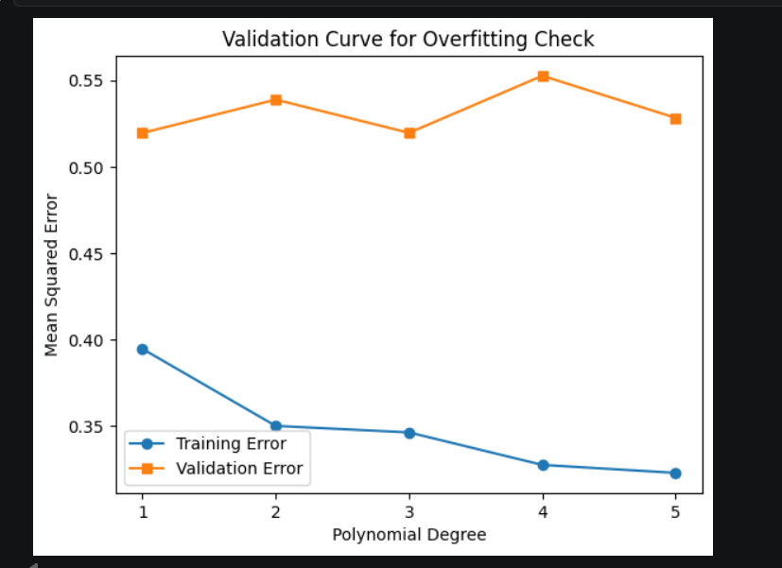

- Add L2 regularization (Ridge regression) to your polynomial regression model (degree=3) on a Flipkart product price prediction dataset, and compare the model's performance with and without regularization. Use Ridge from sklearn.linear_model and explain any difference in test error.

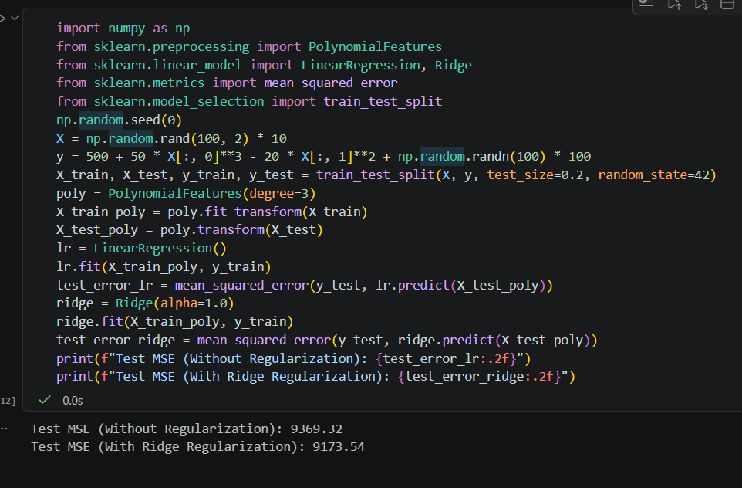

5. Use ChatGPT or Copilot to generate Python code that demonstrates underfitting and overfitting using polynomial regression on a synthetic dataset, then run the code and explain in your own words how model degree affects bias and variance.

